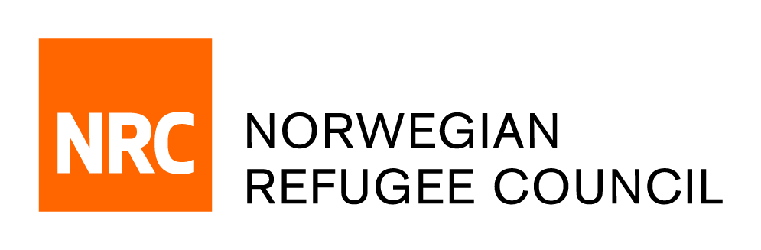
NRC Sudan
PREQUALIFICATION OF SUPPLIERS/FRAMEWORK AGREMENTS – 2022-23
N°: 003 /NRC–NOT/SD/2022

Call for Graphic Designers
Brief about NRC:
The Norwegian Refugee Council (NRC) is a non-governmental, humanitarian organization with 60 years of experience in helping to create a safer and more dignified life for refugees and internally displaced people. NRC advocates for the rights and provides assistance, protection and durable solutions to refugees and internally displaced persons worldwide.
NRC has been operating in Sudan since early 2020 providing assistance with Emergency shelter, Livelihoods and Food Security, Water, sanitation and hygiene sectors, Information and Legal Counselling and Education.
NRC- Sudan invites interested and eligible entities to submit their application for the purpose of establishing long term agreements and Prequalification for the following category numbers and corresponding description of services for the year 2022/23
FRAMEWORK AGREEMENTS AND SUPPLIER PREQUALIFICATION 2022/23
Category | Description
NRC-SD/2022/37 | Graphic designing (NRC is looking for a graphic designer/ entity to transform ideas into visual communication which combines images, illustrations, words, or any other visual representation to convey information to an audience.)

Terms of Reference (ToR) - GRAPHIC DESIGNER

- Objective:
NRC Sudan is looking for a graphic designer able to design, depending on needs, the following products:
- External publications targeting an international and domestic audience, in compliance with NRC and donor branding,
- Communication/promotional products, targeting communities that NRC serves and domestic audience, in compliance with NRC branding
- Information, Education and Communication materials targeting communities that NRC serves, adapted to the cultural context of Sudan, and in compliance with NRC and donor branding
The designer should be able to deliver design files in soft copy to NRC in a timely manner, and in line with specific ToRs that will be delivered by NRC. The designer should be able to design products both in English and Arabic

- Scope of work
- External Publications – this includes Annual Reports, Assessment reports, Researches
- Propose overall design style and format options, adapted to the publication’s nature and target audience
- Design the entire publication based on script delivered by NRC. This includes developing illustrations, icons, maps, charts and other designs as relevant
- Adhere to NRC identity requirements and rules – including branding colors, typeface and other requirement
- Provide drafts to NRC focal point for revision and amendment and amend designs after feedback
- Ensure final graphics and layouts are visually appealing, reader-friendly and on-brand
- Produce appropriate electronic and print versions
- When relevant, provide English and Arabic version of the design

- Communication/promotional products, targeting communities that NRC serves and domestic audience, in compliance with NRC branding and relevant donor branding. This includes: calendars, complex flyers, folders, notebooks
- Propose overall design style and format options, adapted to the product and target audience
- Design the entire product based on NRC identity requirement and donors requirement – including branding colors, typeface, logos and other requirement
- Provide drafts to NRC focal point for revision and amendment and amend designs after feedback
- Ensure final graphics and layouts are visually appealing, reader-friendly and on-brand
- Produce layout ready for production/printing. When necessary, communicate with printing company to advice on the production/printing and make adjustment when necessary.
- Provide when relevant, English and Arabic version of the design (or other languages if relevant)

- Information, Education and Communication materials/ awareness campaign material targeting communities that NRC serves, adapted to the cultural context of Sudan, and in compliance with NRC and donor branding. This includes: drawings, booklets, manuals, posters and flyers reflecting NRC messages on different topics (education, water sanitation and hygiene, legal and civil documentation, etc.)
- Propose designs/drawings/animations according to NRC specific brief
- Ensure that the designs are adapted to the target audience, easily understandable, and in line with the local context (culturally appropriate)
- Ensure that the designs convey simple and direct messages to the targeted audience, in line with purpose of the awareness campaign
- Propose formats (booklets, posters etc.) that are adapted to the targeted locations
- Produce layout ready for production/printing. When necessary, communicate with printing company to advice on the production/printing and make adjustment when necessary.
- Provide Arabic versions, and if relevant, English versions or other languages

- NRC Duties:

- Initial briefing and clarification of the scope of work for each product. This includes
  - Providing specificities of each product (number of pages, number of design)
  - Providing target audience for each product
- Contents of the product, i.e. script, photographs, key messages
- Identity/ Branding rules (logos, color scheme, typeface, guidelines) both for NRC and relevant donor
- NRC will regularly review drafts of design and layout and revert back with feedback in a timely manner

- Qualifications of designer:

- Graphic Designer must be fluent in both English and Arabic.
- Graphic Designer should be registered.
- Graphic Designer should be able to provide proof of relevant taxation registration.
- Graphic Designer’s awareness of context and of humanitarian sector (is a plus)
- Graphic Designer must provide sample of designed reports and publications (Mandatory)
- Graphic Designer sample of designed of IEC material (if available)
- Provide Resume and cover letter
- Provide sample of designed complex banners (Drawings, painted effects, and illustrations)
- Graphic Designer should have experience in
  - Publications
  - Promotional Products
  - Drawing, animations

Requirements.

- Provide sample of designed reports and publications (Mandatory)
- Provide sample of designed of IEC material (if available)
- Provide Resume and cover letter
- Provide sample of designed complex banners (Drawings, painted effects, and illustrations)
- Solid understanding of design principles as they relate to typography, layout, and color
- Adobe InDesign, Illustrator, and Photoshop skills required. Knowledge of website design/management, photography, or video editing a plus.

How to apply.

- Request the call of interest document from sd.procurement@nrc.no
- All completed documentations should be emailed to the following email address – sd.tenders@nrc.no. and for any queries, please contact NRC Sudan procurement unit at sd.procurement@nrc.no
- Deadline: 04:00pm on the 21st of December 2022
- Late submissions will not be accepted.

Norwegian Refugee Council reserves the Right to Accept or reject any tender application and is not bound to give reasons for this decision thereof.

